

**System Setup Instruction**

**Synergi**

**Version 1.00**

**07/11/2013**

**Authors**

**Synergi Support Team**

**Contents**

Version 3

Supporting Documentation 3

1. Document Summary 4

1.1 Document Purpose 4

2. Systerm Setup 5

2.1 Register License to start application 5

2.2 Create new organisation and organisation admin account 5

2.3 Setup a new Site and site admin account 5

2.3.1 Create Site Group 5

2.3.2 Setup a new Site 5

2.3.3 Setup Data for Site 7

Version

|  |  |  |
| --- | --- | --- |
| **Spec Version No.** | **Date** | **Change Summary** |
| Version 1.00 | 07/11/2013 | Document Created |
|  |  |  |
|  |  |  |
|  |  |  |
|  |  |  |
|  |  |  |
|  |  |  |
|  |  |  |
|  |  |  |
|  |  |  |
|  |  |  |

Supporting Documentation

|  |  |  |  |
| --- | --- | --- | --- |
| **Document Name** | **Date of Creation** | **Description** | **Change Summary** |
|  |  |  |  |
|  |  |  |  |
|  |  |  |  |
|  |  |  |  |
|  |  |  |  |
|  |  |  |  |
|  |  |  |  |
|  |  |  |  |
|  |  |  |  |
|  |  |  |  |
|  |  |  |  |

# Document Summary

### Document Purpose

The purpose of this document is to guide user how to setup the system after deployment. This will show how to register the application with license, set up the Organisation, create user accounts, setup a site,

# Systerm Setup

### Register License to start application

* Login as PortalAdmin user, the app will redirect to “License Admin” page automatically. (Or user can click Home => Administration => License Admin).
* Input License Key into the textbox and click “Add/Refresh” button. A line of license key information will be added in the grid as below. After this step, the application is registered. With this step user can refresh the license key.

Note : the license key is only valid for some registered domain names, so the domain of the website should be the same with the registered domain name in license.

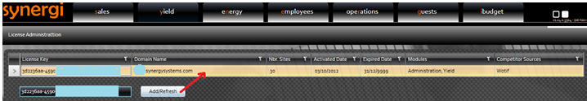

### Create new organisation and organisation admin account

* Login as PortalAdmin user, go to page “Home -> Administrator -> Portal Admin”.
* In section Competitor Source Administration, there are some records of Competitor Sources that the license have. User only input UserName/Password/Schedule Time (if needed) for each source, then click Save.

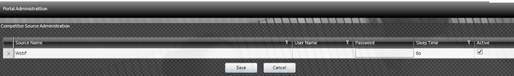

* There is a default Organisation on the Grid. Just change the name and Authorisation Code and click “Save” button. Then we can edit/save the contact information of this organisation.
* Create a Organasation Administrator user by inputting username, password and email. Then check “Account Approved” check box and click “Save Button”. The system will create and user account with Organisation Administrator roles for this Organisation.

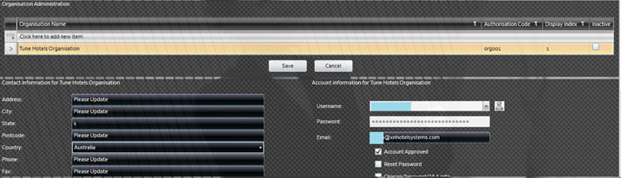

### Setup a new Site and site admin account

### Create Site Group

* Login as Organisation Administrator user account (created above). Go to Home => Administration => Site Group Admin to create site groups.

### Setup a new Site

* Go to Home => Administration => Site Admin to create new site.
* Input values into the grid on top (ex : Name, license key, Star rating, country….) and click “Save” button to create a new Site.
* User should check “Link Departments Automatically” checkbox on the left top corner to link the new site with all Departments automatically. Then we can go to Home => Admintration => Link Department page to remove un-needed Departments.

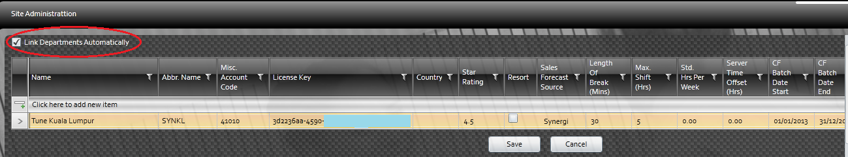

* Choose this site and fill needed values into below sections like Site Group, Default Timecard Shift Rounding Times, Site Accommodation, Site Specific Settings, Culture and Layout Settings, SMS Settings, Mail Settings, Forecast Inflation.

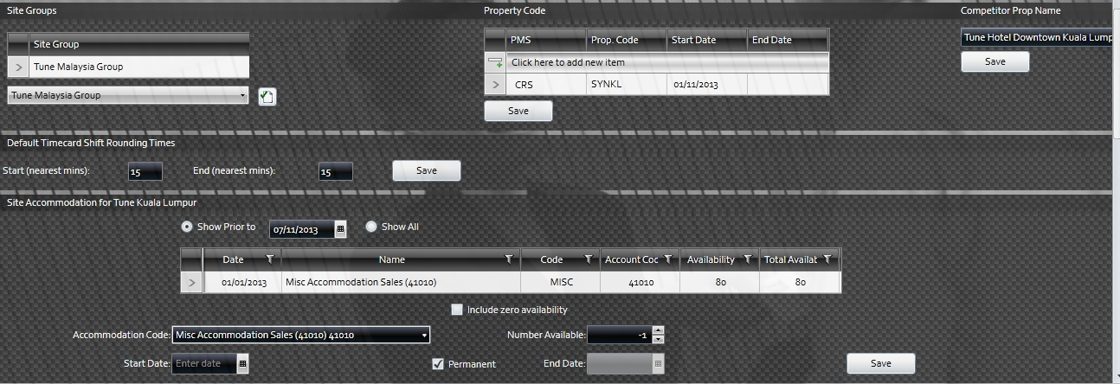

* Go to Home => Security => User Account Admin, fill Username, Password, email address then click Save to create a new account.

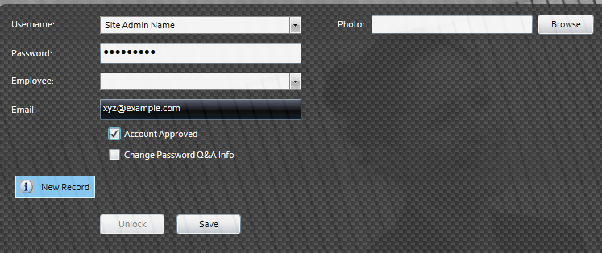

* Go to Home => Security => User Role Authorisation, input Site Admin name in the Username combobox, press enter or tab. In “Roles” tab, click the green button on the right to add role for this account, here we add 2 roles : Site Administrator and Security Admin. Site Administrator is the role to manage the data of a site. Security Admin is the role to manage user account and roles.

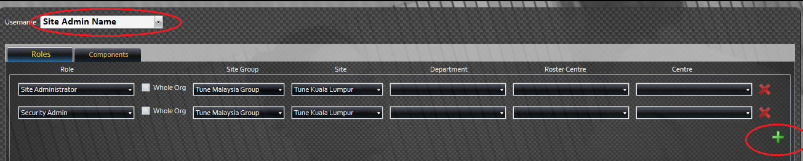

### Setup Data for Site

* Go to Yield => Administration => Site Demand Level revPAR Adminstration to setup season values for sites.

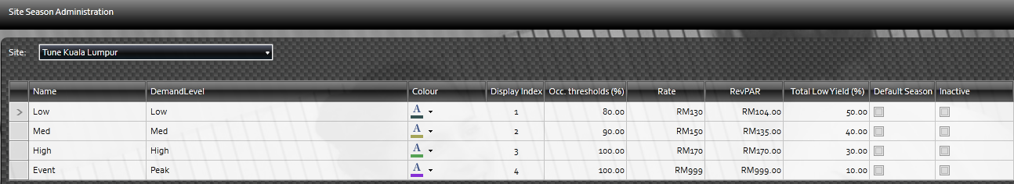

* Go to Yield => Administration => Daymarker Adminstration to setup daymarker for each type.

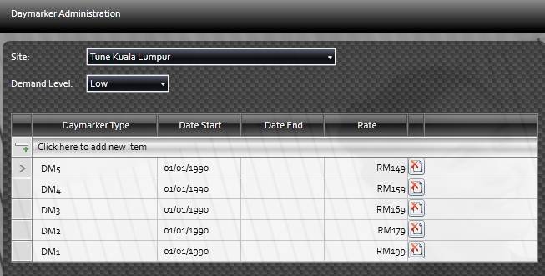

* Go to Yield => Administration => Yield Level Adminstration to setup daymarker for each type.

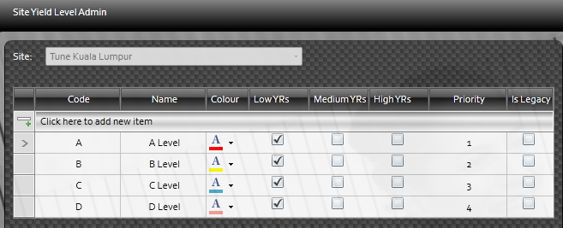

* Go to Home => Administration => Room Types to add Room Type.

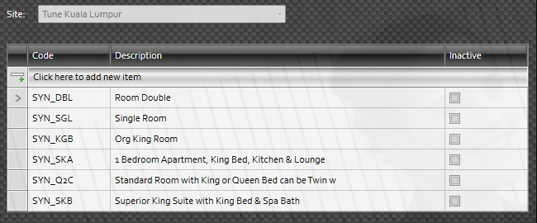

* Go to Yield => Administration => Yield Structure Administration to build the hierarchy structure of Yield such as Yield Level, Rate Group, Rate Code (Or Rate Detail Block), Room Types.

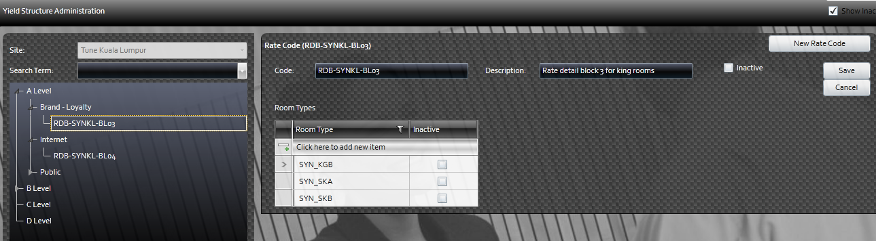

* Go to Yield => Administration => Yield Allocation Template to build the template (or default values) for room night Allocation.

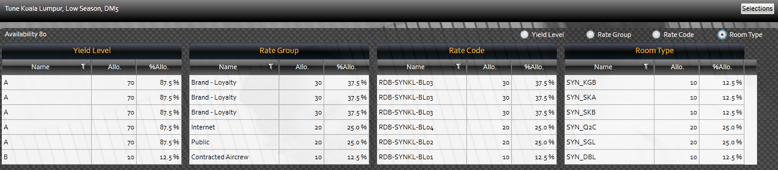

* Go to Yield => Rate Management => Demand Level Calendar to set season for each day by right click on a day cell. Or we can click “Edit Range” to apply value for a whole period. In this page, we can switch to Daymarker to edit the daymarker also (by select Daymarker in the right dropdown box)

